DrugFacts: What is marijuana?
http://www.drugabuse.gov
July 2015

What is marijuana?
Marijuana refers to the dried leaves, flowers, stems, and seeds from the hemp plant, Cannabis sativa. The plant contains the mind-altering chemical delta-9-tetrahydrocannabinol (THC) and other related compounds.

Marijuana is the most commonly used illicit drug in the United States. Its use is widespread among young people. According to a yearly survey of middle and high school students, rates of marijuana use have steadied in the past few years after several years of increase. However, the number of young people who believe marijuana use is risky is decreasing.

How does marijuana affect the brain?
Short-term effects
THC acts on specific brain cell receptors that ordinarily react to natural THC-like chemicals in the brain. These natural chemicals play a role in normal brain development and function.

Marijuana overactivates parts of the brain that contain the highest number of these receptors. This causes the "high" that users feel. Other effects include:
- Altered senses (for example, seeing brighter colors)
- Altered sense of time
- Changes in mood
- Impaired body movement
- Difficulty with thinking and problem-solving
- Impaired memory

Long-term effects
Marijuana also affects brain development. When marijuana users begin using as teenagers, the drug may reduce thinking, memory, and learning functions and affect how the brain builds connections between the areas necessary for these functions.

A study showed that people who started smoking marijuana heavily in their teens and had an ongoing cannabis use disorder lost an average of eight IQ points between ages 13 and 38. The lost mental abilities did not fully return in those who quit marijuana as adults. Those who started smoking marijuana as adults did not show notable IQ declines.

What are the other health effects of marijuana?
- Breathing problems. Marijuana smoke irritates the lungs, and frequent marijuana smokers can have the same breathing problems that tobacco smokers have. These problems include daily cough and phlegm, more frequent lung illness, and a higher risk of lung infections. Researchers still do not know whether marijuana smokers have a higher risk for lung cancer.

- Increased heart rate. Marijuana raises heart rate for up to 3 hours after smoking. This effect may increase the chance of heart attack. Older people and those with heart problems may be at higher risk

- Problems with child development during and after pregnancy. Marijuana use during pregnancy is linked to increased risk of both brain and behavioral problems in babies. If a pregnant woman uses marijuana, the drug may affect certain developing parts of the fetus’s brain. Resulting challenges for the child may include problems with attention, memory, and problem-solving. Additionally, some research suggests that moderate amounts of THC are excreted into the breast milk of nursing mothers. The effects on a baby’s developing brain are still unknown

Mental effects
- Temporary hallucinations—sensations and images that seem real though they are not
- Temporary paranoia—extreme and unreasonable distrust of others
- Worsening symptoms in patients with schizophrenia (a severe mental disorder with symptoms such as hallucinations, paranoia, and disorganized thinking)

Marijuana use has also been linked to other mental health problems, such as depression, anxiety, and suicidal thoughts among teens. However, study findings have been mixed.

How Does Marijuana Affect a User’s Life?
Compared to nonusers, heavy marijuana users more often report the following:
- lower life satisfaction
- poorer mental health
- poorer physical health
- more relationship problems

Users also report less academic and career success. Marijuana use is linked to a higher likelihood of dropping out of school. It is also linked to more job absences, accidents, and injuries.

Is marijuana addictive?
Contrary to common belief, marijuana can be addictive. Research suggests that 30 percent of users may develop some degree of problem use, which can lead to dependence and in severe cases takes the form of addiction.⁹ People who begin using marijuana before age 18 are 4 to 7 times more like than adults to develop problem use. Dependence becomes addiction when the person can't stop using marijuana even though it interferes with his or her daily life.

DrugFacts: Is marijuana medicine?
http://www.drugabuse.gov
July 2015

What is medical marijuana?
The term medical marijuana refers to using the whole unprocessed marijuana plant or its basic extracts to treat a disease or symptom.

Scientific study of the chemicals in marijuana, called cannabinoids, has led to two FDA-approved medications that contain cannabinoid chemicals in pill form. Continued research may lead to more medications.

Because the marijuana plant contains chemicals that may help treat a range of illnesses or symptoms, many people argue that it should be legal for medical purposes.

Why isn’t the marijuana plant an FDA-approved medicine?
The FDA requires carefully conducted studies (clinical trials) in hundreds to thousands of subjects to determine the benefits and risks of a possible medication. So far, researchers have not conducted enough large-scale trials that show that the benefits of the marijuana plant (as opposed to its cannabinoid ingredients) outweigh its risks in patients it is meant to treat.

How might cannabinoids be useful as medicine?
Currently, the two main cannabinoids from the marijuana plant that are of medical interest are THC and CBD.

THC increases appetite and reduces nausea. The FDA-approved THC-based medications are used for these purposes. THC may also decrease pain, inflammation (swelling and redness), and muscle control problems.

CBD is a cannabinoid that does not affect the mind or behavior. It may be useful in reducing pain and inflammation, controlling seizures, and treating mental illness and addictions.

Animal studies have shown that marijuana extracts may help kill certain cancer cells and reduce the size of others. Evidence from one cell culture study suggests that purified extracts from whole-plant marijuana can slow the growth of cancer cells from one of the most serious types of brain tumors. Research in mice showed that treatment with purified extracts of THC and CBD, when used with radiation, increased the cancer-killing effects of the radiation.

Scientists are also conducting preclinical and clinical trials with marijuana and its extracts to treat numerous diseases and conditions, such as the following:
- Autoimmune diseases (diseases that weaken the immune system):
  - HIV/AIDS
  - Multiple sclerosis (MS), which causes gradual loss of muscle control
  - Alzheimer’s disease, which causes loss of brain function, affecting memory, thinking, and behavior
- Inflammation
- Pain
- Seizures
- Substance use disorders
- Mental disorders

Marijuana stops child's severe seizures
By Saundra Young, CNN
August 2013

Paige Figis had consistently voted against marijuana use. That was before Dravet Syndrome entered the lives of their family. Because of the condition, her 5-year-old daughter Charlotte had lost the ability to walk, talk and eat. She was having 300 grand mal seizures a week. Her heart had stopped a number of times.

She was 5 when the family learned there was nothing more the hospital could do. That's when Paige decided to try medical marijuana.

Scientists don't fully understand the long-term effects early marijuana use may have on children. Studies that show negative effects, such as diminished lung function or increased risk of a heart attack, are primarily done on adult marijuana smokers. But Charlotte wouldn't be smoking the stuff.

Paige found a Denver dispensary that had a small amount of a type of marijuana called R4, said to be low in THC and high in CBD. She paid about $800 for 2 ounces.

"We were pioneering the whole thing; we were guinea pigging Charlotte," Paige said. "This is a federally illegal substance. I was terrified to be honest with you."

But the results were stunning.

The seizures stopped for an hour, and then another. And for the following seven days.

Today, Charlotte, 6, is thriving. Her seizures only happen two to three times per month, almost solely in her sleep. Not only is she walking, she can ride her bicycle. She feeds herself and is talking more and more each day.

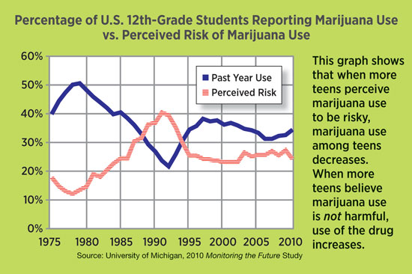
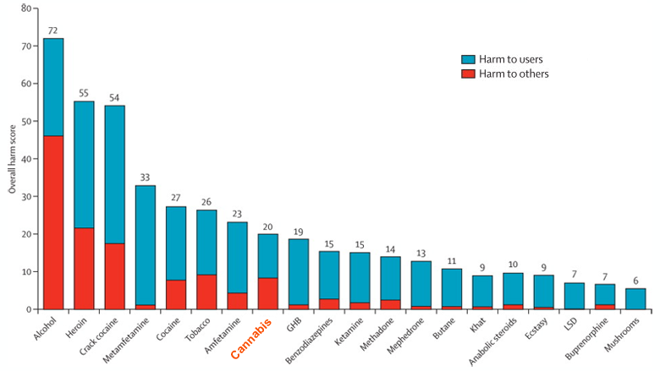
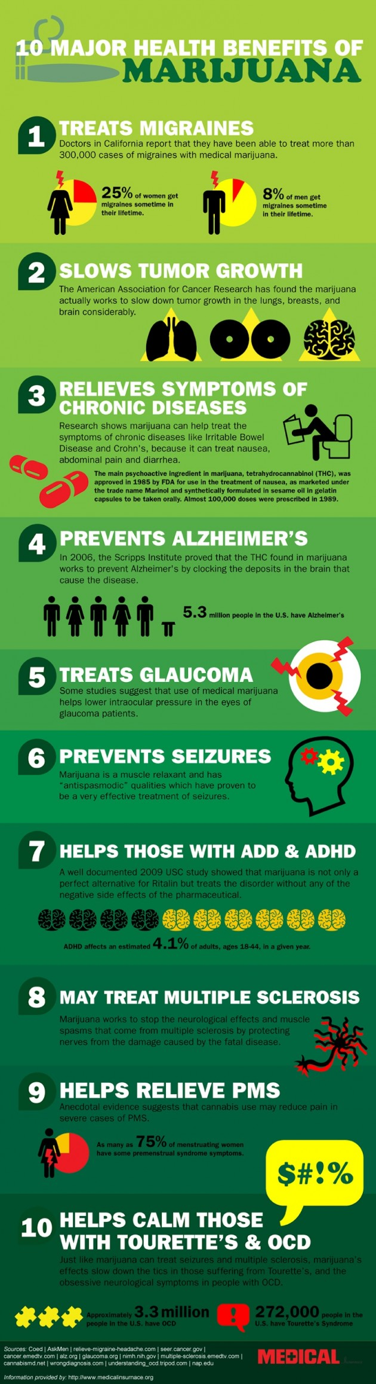
Source: Visual.ly

"Drug Harms in the UK: A Multicriteria Decision Analysis" November 1, 2010, Lancet (academic journal)

