Making Inferences

What is an inference?

What is textual evidence?

Why is it important to learn how to make inferences when reading?

Make some inferences about the following images or passages:
Image/Passage | What I think happened/is happening  (Inference) | Why I think that  (Textual/Visual evidence)
“And I know she ain’t saying what she want a say either and it’s a strange thing happening here cause nobody saying nothing.” (The Help, 35)
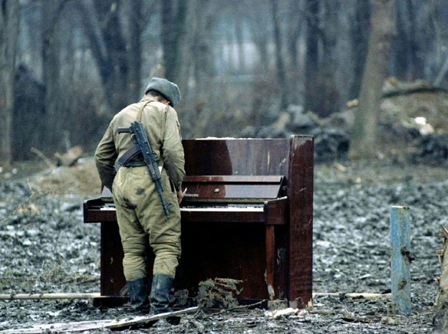
“For sale: baby shoes. Never worn.” – Ernest Hemingway
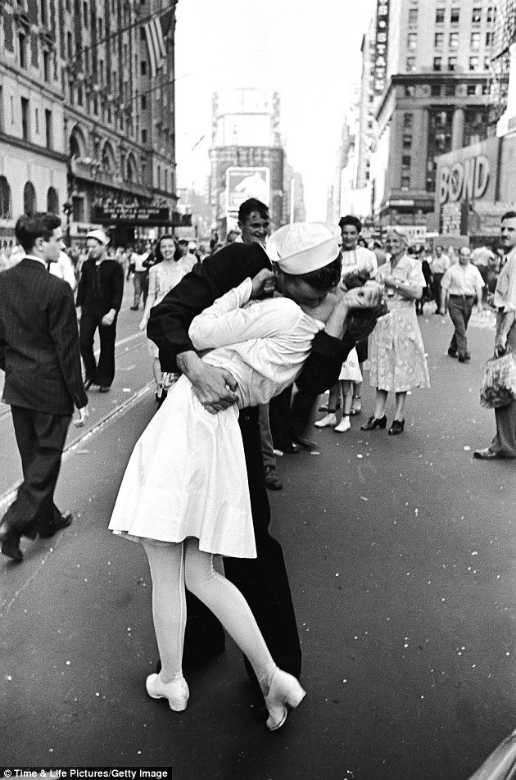
“When I go in the kitchen, Miss Skeeter’s in there. She leaning against the counter, got a serious look on her face, even more serious than usual…When I sneak a look over, she’s still got her worried eyes on that window.” (The Help,11)
