Outline for Character Analysis Paper

What questions should you ask when analyzing a character?
- Who is this person? Specifically, what are the complexities within their personality?
- What does this person want? What are the motivations for their actions?
- How does this person change through the course of the novel?

What is indirect characterization?

Example from the song:

What is direct characterization (Include 4 most common ways)?

Example from the song:

Directions: Using what we have talked about in class and written above, you are going to create an outline for a paper that analyzes 3 characters in the novel The Help. Remember to use specific examples and/or quotes from the novel about the specific character. Include direct as well as indirect characterization examples and make sure to include complexities in each character. Don’t just give a surface summary of what the character is like. This is NOT a book report summary; this should be an in-depth look at how characters are complex and change over time. Fill out the web on the back of this paper, and then use the rubric you were given to write your essay. Good luck!

Here is a list of some main characters you may choose from. (You can also do other characters not mentioned here if you can find adequate support in the novel to do a character analysis):
- Aibileen Clark
- Eugenia “Skeeter” Phelan
- Hilly Holbrook
- Celia Foote
- Minny Jackson
- Elizabeth Leefolt
- Stuart Whitworth
- Charlotte Phelan (Skeeter’s mother)
- Missus Walters (Hilly’s mother)
- Johnny Foote

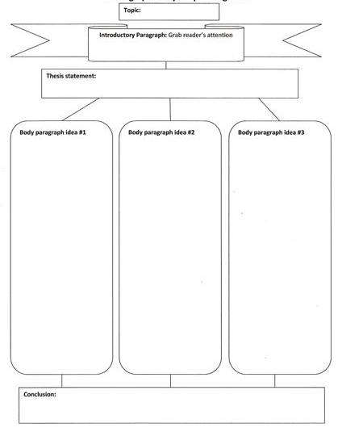

Rubric for Character Analysis Paper

Standard: | 20 | 10 | 0
Thesis Statement | Thesis statement is clearly stated and maintained throughout the paper. It addresses an aspect of characterization manifested by all 3 characters. | Thesis statement is unclearly stated or too surface. The characters selected do not support thesis statement. | Thesis statement is absent.
Character Analysis | Essay gives an in-depth analysis of 3 characters with specific mention to their motivations, complexities in their personality, and how they change throughout the novel. | Essay gives an analysis of characters, but it is missing one of the elements of analysis (motivation, complexity, change) or analysis is done on fewer than 3 characters. | Analysis is surface and incomplete. Essay is missing characters and does not address the elements of character analysis.
Evidence of Characterization | Essay contains both indirect and direct examples of characterization through specific quotes or events in the novel | Essay has some quotes and examples, but they are not enough to support the character analysis of all 3 characters. | Essay is missing evidence of characterization and lacks either indirect or direct characterization. There are not quotes or examples from the novel used.
Conclusion | Conclusion restates the thesis and draws on commonalities and/or patterns between all 3 characters. | Conclusion wraps us the essay but does not find a commonality between the characterization of all 3 characters. | Conclusion is weak and does not restate the thesis or find commonalties between the 3 character analyses.
Conventions | Minimal or no spelling, grammar, or punctuation mistakes. | Spelling, grammar, and punctuation mistakes are present, but they are not distracting to the overall flow of the paper. | Spelling, grammar, and punctuation mistakes are distracting to the flow of the paper.
/100

Title:

Character 1 (Make sure to
address all 3 questions
about analyzing a character
on the front of this paper)

Character 2 (Make sure to
address all 3 questions
about analyzing a character
on the front of this paper)

Character 3 (Make sure to
address all 3 questions
about analyzing a character
on the front of this paper)

